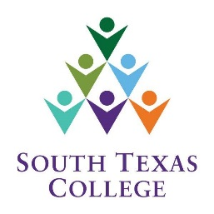

193075 - Computer Science CITP
Dual Credit/Adjunct Faculty Department Meeting
[Saturday, August 21, 2021]
Microsoft Teams
1:30 p.m. – 2:30 p.m.

AGENDA

- Department Updates
- Guest Speaker – Nicholas Hinojosa, Blackboard Ultra Training
- Incompletes
- Section outlines and Concourse
- StarFish
- Don’t forget to Remote check-in: COSC2021
- Acknowledging FLAC and Concourse
- Questions/Concerns?

